**Five Senses Match Up**

Draw a line from the sense to the picture that you would most likely use the sense.







C:\Users\kprophet\AppData\Local\Microsoft\Windows\Temporary Internet Files\Content.IE5\VMLMXU4V\MC900140627[1].wmf

C:\Users\kprophet\AppData\Local\Microsoft\Windows\Temporary Internet Files\Content.IE5\YO08BUT2\MC900411049[1].wmf

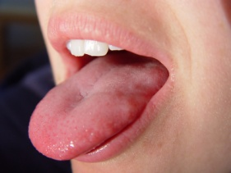



C:\Users\kprophet\AppData\Local\Microsoft\Windows\Temporary Internet Files\Content.IE5\VMLMXU4V\MC900211478[1].wmf

C:\Users\kprophet\AppData\Local\Microsoft\Windows\Temporary Internet Files\Content.IE5\YO08BUT2\MC900281284[1].wmf

